使用说明书

User Manual

**1.适配车型/Compatible with the following models**

Fits: MX-5 2016 to 2020  
Fits: CX-3 2016 to 2019  
Fits: CX-5 2015 to 2020  
Fits: CX-9 2016 to 2020  
Fits: Mazda 2 2016 to 2019  
Fits: Mazda 3 2014 to 2018  
Fits: Mazda 6 2016 to 2020

1. **注意事项：**

**2-1.**在开始安装之前，必须首先更新固件。如果使用的是旧版本的CMU软件，则可能无法识别与CarPlay/Android Auto兼容的USB集线器。软件必须是v70.00.21或更高版本。如果没有，请确保更新软件。一旦CMU连接到CarPlay/Android Auto兼容USB集线器，软件就无法更新。

**2-1.**The firmware MUST BE UPDATED FIRST before beginning the installation. If an older version of the CMU software is being used, the CarPlay/Android Auto-compatible USB hub may not be recognized. The software must be v70.00.21 or later. If not be sure to update the software. Once the CMU has been attached to the CarPlay/Android Auto-compatible USB hub, the software cannot be updated.

**2-2.**安装时，请确保整车断电

**2-2.**During installation, please ensure that the vehicle is powered off

1. 产品安装接线/Connection Diagram

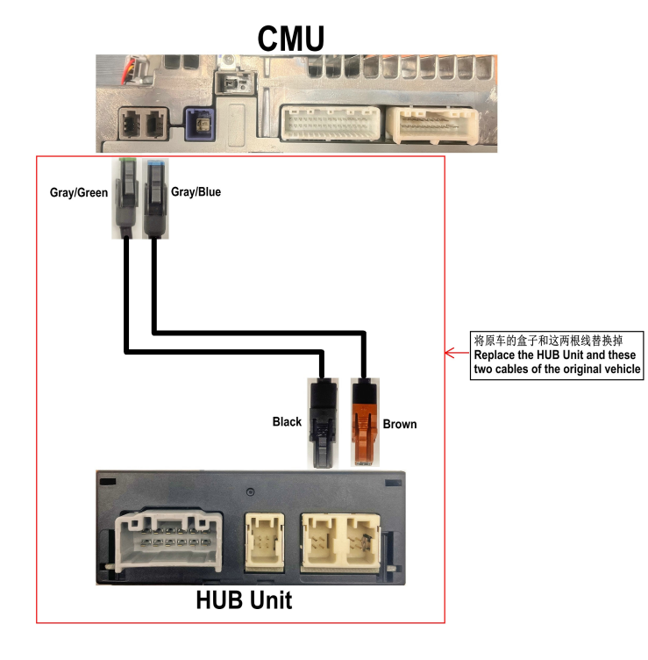

1. **产品使用**

**4-1.Apple CarPlay**

通过Apple CarPlay, 可以使用iPhone拨打电话、发送或接收消息、听音乐，或使用地图搜索目的地，此外，还可以使用Siri进行语音识别

Apple CarPlay allows you to make calls, send or receive messages, and listen to music using your iPhone with the Mazda Connect, or search for destinations using the maps,. In addition, voice recognition using Siri is available.

**4-1-1.**将Apple原装连接线缆牢固插入下图红线标记的USB端口

Insert the Apple-genuine connector cord into the USB port marked by red line.

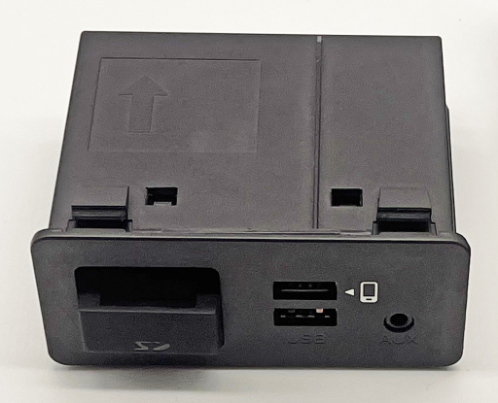

**4-1-2.**Apple CarPlay主屏幕

Apple CarPlay home screen

按下图红色线圈内的任一按钮即可激活Siri

Press any button in the red coil as shown below to activate Siri

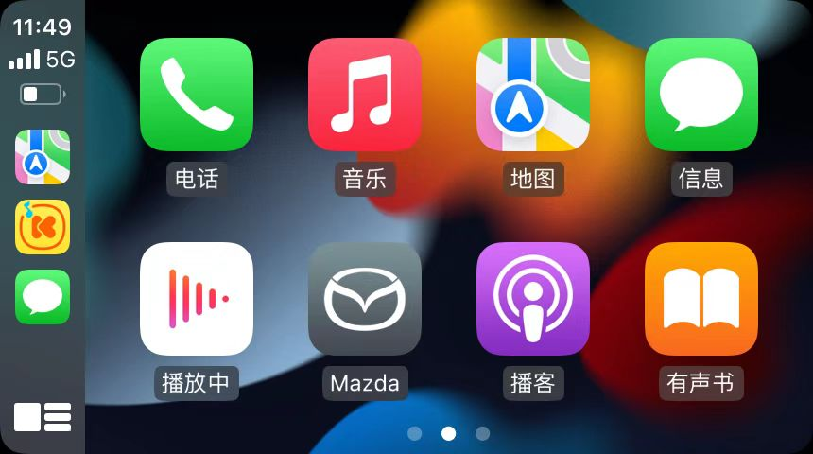

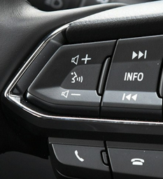

4-2.Android Auto

Android Auto is an application which allows the operation of an Android Smartphone using the Mazda Connect. To operate the smartphone such as messages, music, and maps

Android Auto是一款允许使用马自达Connect操作Android智能手机的应用程序。可以用来操作手机例如信息、音乐和地图等。

**4-2-1.**将Android原装连接线缆牢固插入下图红线标记的USB端口

Insert the Android-genuine connector cord into the USB port marked by red line.



**4-2-2.**Android Auto主屏幕

Android Auto home screen

按下图红色线圈内的任一按钮即可激活Siri

Press any button in the red coil as shown below to activate Siri

注意/Caution:

1.请不要让连接到USB端口的线缆缠住选档杆/换档杆

2.如果电线缠结，可能会分散您的驾驶注意力，导致意外事故。

Do not allow the cord connected to the USB port to get tangled in the selector lever/shift lever

If the cord gets tangled, it could be a distraction to your driving and result in an unexpected accident.